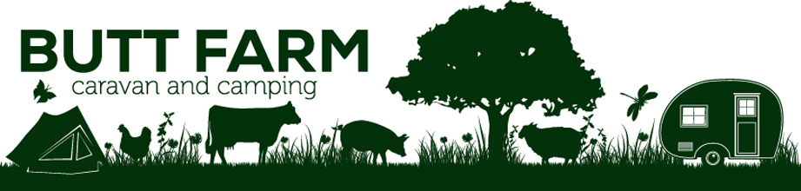
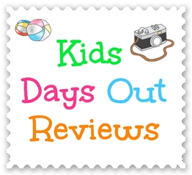
Hello, and welcome to Beverley!
I’m Joanne and I write a family travel blog www.KidsDaysOutReviews.co.uk where I talk about family days out and holidays around the UK.
Here are my recommendations for things to do with your family while you are visiting Butt Farm

In Beverley
Treasure House - on Lord Roberts Road on the edge of the town centre is the Treasure House. This is a council-owned centre which houses the public library, the art gallery, the tourist information centre, and a museum dedicated to local life and history. There are some dressing up outfits for children, and a few things to bash/prod. The café is pretty good too. FREE. Post code HU17 8HE
The Guilds’ Town Trail - throughout the town centre, you can follow the town trail and learn more about Beverley’s history. You may be able to pick up a trail map from the Tourist Information Centre (part of The Treasure House) - if not, download it at http://providerfiles.thedms.co.uk/eandamedia/YS/2297988_1.pdf
Mega Fun - the nearest under 10s soft play centre is on Annie Reed Road on the Eastern edge of Beverley - post code HU17 0LF. It’s good for under 10s, and the food is reasonable too. It gets busy on wet days during the school holidays, but parking is plentiful and free.
Beverley Westwood - the common land in Beverley is famous, and fantastic for dog walking and a little run around. Post code is HU17 8LY. No toilets, but often an ice-cream or coffee wagon. Free parking but look out for any restrictions.
Beverley Leisure Centre - they do public swim sessions, have a café, and do badminton court hire. Call them to check session times as they can change - 01482 395230. They do have tots soft play on selected mornings. Post code - HU17 0LT

Flemingate - a range of shops and eateries, and also Parkway Cinema. Multi-storey car parking available - post code HU17 0PW

Hull City Centre
You can access Hull city centre via bus (X46/X47 Hull to York), train, or car. There are lots of things to do here:-
Cinemas, restaurants, shops
- Ferens Art Gallery, Queen Victoria Square - FREE
- The Maritime Museum, Queen Victoria Square - FREE
- Wilberforce House, High Street - FREE
- Streetlife Museum, High Street - FREE
- The Hull and East Riding Museum, High Street - FREE
- Seven Seas Fish Trail - FREE, collect a map from the Tourist Office (under Hull City Hall on Queen Victoria Square)
- Dinostar, Humber Street
- The Deep, Sammy’s Point
The land train leaves from outside the City Hall, Queen Victoria Square and goes around the old town and up to The Deep, and back again.

Kingswood in Hull
On the northern tip of Hull, Kingswood Retail Park has Hollywood Bowl, Cineworld, various eateries (Frankie & Benny’s, Chiquitos, Pizza Hut), a 24-hour ASDA, and lots of other handy shops. Is about a ten minute drive from Butt Farm - post code HU7 3DA (ASDA)

Indoor entertainment
There are two trampoline parks - Rebound in Hull (HU7 0YF) and Gravity in Hull city centre (HU2 8LN). Parking is easier for Rebound - Gravity is part of St Stephen’s shopping centre which has a multi-storey pay and display car park. At St Stephen’s there’s also Rock Up Hull (an indoor climbing centre for children), an amusement arcade, a cinema (Reel), and a range of eateries.
Prince’s Quay in Hull city centre has shops, eateries, a cinema (Vue), an amusement arcade, and a bowling alley. Multi-storey parking available. HU1 2PQ
TASR Skate Park is on Tokenspire Business Park in Woodmansey - HU17 0TB. You can hire scooters, BMX bikes, boards, and protective wear there. Members or guests welcome. Check www.tasr.co.uk for prices and opening times.

Soft play
Mega Fun is Beverley’s only soft play centre HU17 0LF
Monkey Bizness is the nearest soft play in Hull HU7 0YQ
Big Fun is better for older children - HU5 4JB

Outdoor Entertainment
Let Loose Yorkshire - in Woodmansey, HU17 0RS. This is an outdoor aerial fun park with zip wires, slides etc. Seasonal opening only. Please check the website for more information. It is next door to a garden centre, and there is a café.
Go Ape! (Dalby forest) - Like Let Loose only in a Forestry Commission forest - YO18 7LT. You may have to pre-book through their website. Is about an hour’s drive away in North Yorkshire.
William’s Den HU15 2LS - a popular outdoor adventure playground for under 10s. Wellies probably wise in wetter weather. Check their website for current opening hours.
Humber Bridge Country Park HU13 0LN - a FREE country park with walks and bike trails. Good for dog walking. Access to Hessle Foreshore. Head for the Humber Bridge and follow the signs to the tourist information centre or Hessle Foreshore.
Tophill Low YO25 9RH - a Yorkshire Water owned nature reserve. Free parking. Small cost for admission. Good for nature walks and bird watching.
Skidby Mill HU16 5TF - a small museum, café, and play park with good views over the surrounding area. Learn about the inner workings of the mill. Call first on (01482) 848405 as opening hours can vary. Small admission charge for the museum.

Farms / Zoos
Honeysuckle Farm, Hornsea is an outdoor play farm with some indoor attractions. Open from Easter to October - please check their website or Facebook page to be sure. HU18 1BY
Bridlington Birds of Prey and Animal Park YO15 3QF - about a 45 minute drive to this outdoor farm with birds of prey displays and plenty of animal exhibits. Free parking in the Park Rose complex. Check their website for opening hours and prices.

Theme Parks
Flamingoland is about an hour’s drive away near Malton, North Yorkshire. Check online for special offers. YO17 6UX

Stately Homes and Gardens
Burnby Hall Gardens, Pocklington YO42 2QF. Mostly outdoors with a small museum and an impressive fish pond. Free parking, admission charge. Check website for seasonal opening hours. Is about a 30 minute drive.
Burton Agnes Hall, Burton Agnes YO25 4NB - lovely stately home and gardens. You can do both or just the gardens. Events on throughout the year. Good to visit at Halloween. Check their website for opening hours and admission charges. Is about a 40 minute drive.
Sewerby Hall, Sewerby YO15 1EA - council owned Sewerby Hall has the old house, a zoo, a playpark, a pitch and putt, and nature walks. You can get the land train from here into Bridlington and back. Is about 50-60 minute drive from Butt Farm, depending on the traffic. Check their website for opening hours and prices. In the Autumn and Winter, it’s often free to get in but the house may not be open.

Further afield
Bondville Model Village, Sewerby YO15 1ER - again, check their website as they do seasonal opening hours. Is a short walk from Sewerby Hall (about a 50-60 minute drive)
Bridlington Leisure Centre/Splash World YO15 2QQ - indoor pool with slides and tots play area. Great value. You may be able to book in advance online - if you can, I recommend you do as it’s popular and you’ll be lucky if you turn up and can get straight in on the next session.
John Bull Candy Kingdom shop and factory tours YO16 4UT. Indoor ‘factory’ tour, See how sweets are made. You might even get to make your own stick of rock. Check website for opening hours and prices. Is a short car drive from Bridlington Birds of Prey and Animal Park
Hornsea Freeport - Retail outlet centre with a good range of shops (Thorntons, Clark’s, Mountain Warehouse etc) with an outdoor play area called Beach Cove, an indoor bug house called Bugtopia, and a couple of cafes. Cash machine. Free parking HU18 1UT - about 40 minutes’ drive from Butt Farm.
Hornsea - Hornsea has a very good leisure centre with pool, amusement arcades, a good beach with shops (though usually only open in the summer), and a choice of fish and chip places. Is 40 minutes’ drive - use HU18 1NQ for Floral Hall where you should have a good chance of getting parked. Check parking restrictions, particularly in the summer.

